Lab 4: Domain Name System  
IPv6

Contents

Introduction to LAB 4 2

Exercise 1: Configure OSPFv3 2

Task 1: Create the topology 2

Task 2: Configure the IPv6 addresses 3

Task 3: Configure and enable OSPFv3 4

Task 4: Verify OSPFv3 and test connectivity 5

Exercise 2: Practice the NSLOOKUP command 7

Task 1: Use NSLOOKUP in noninteractive mode 7

Task 2: Use NSLOOKUP in interactive mode 8

Useful commands for checking your OSPFv3 configurations and troubleshooting 11

# Introduction to LAB 4

During the fundamentals course, you have learned about the basics of OSPF. Then, earlier in the advanced course, you have learned about advanced OSPF and you have configured multi area OSPF as well as redistribution to/from different routing protocols. Now, you are going to configure OSPFv3, which is based on IPv6.

The second exercise will be about DNS and more specifically about the usage of the NSLOOKUP command.

# Exercise 1: Configure OSPFv3

In this exercise, you are going to configure OSPFv3 in a multi-area configuration, using only IPv6 addresses.

## Task 1: Create the topology

In **Cisco Packet Tracer**, use 2911 routers to create the topology. You will need 4 routers from this type. Connect them as per the picture below. You can use the drawing tools to visually represent the different OSPF areas that you are going to configure later.

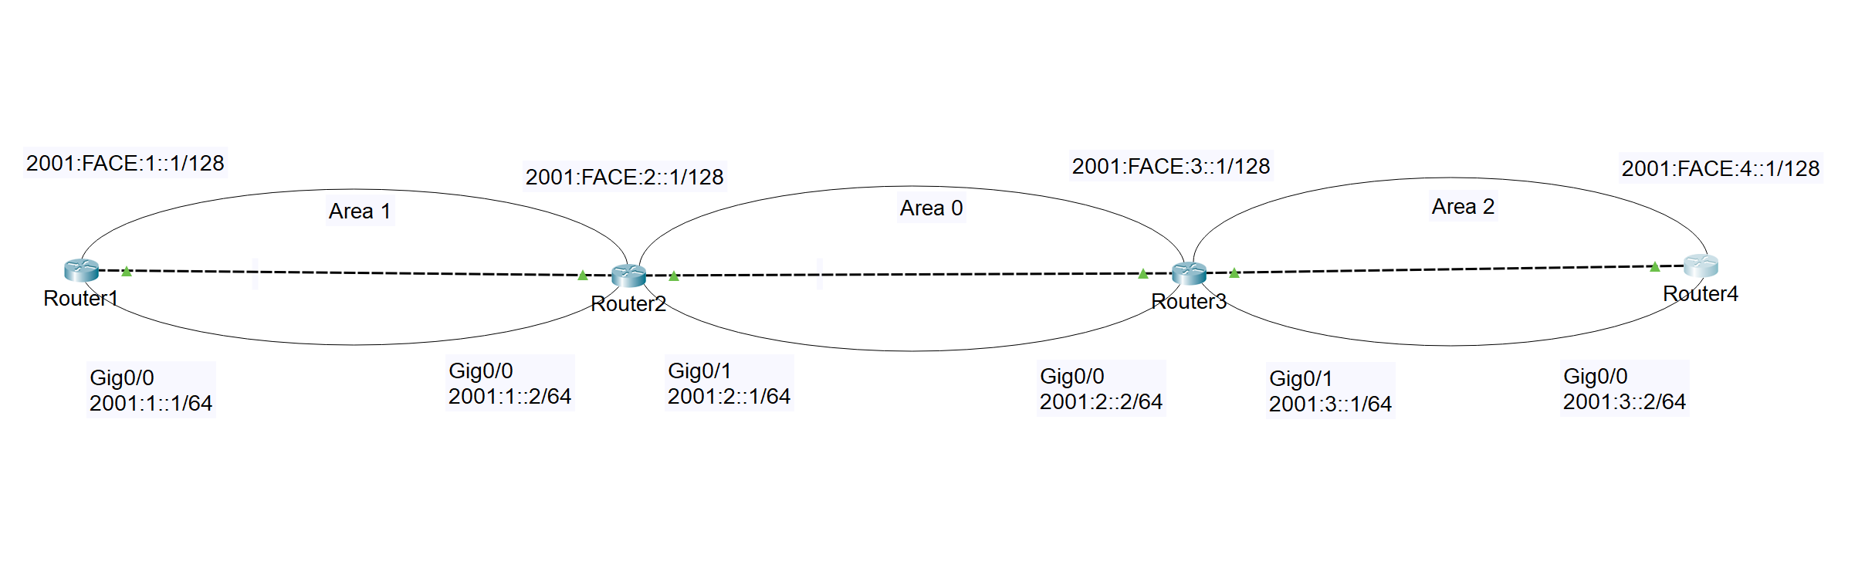

## Task 2: Configure the IPv6 addresses

In this network, we have 4 routers and 10 IPv6 addresses – these are for the connections between the routers and also each router will have a loopback interface with IPv6 address.

The IPv6 addresses are shown on the topology picture but you can also use the table below to assign them.

Note: To assign an IPv6 address to an interface, use the **ipv6 address** command from the interface configuration mode, for example:

**ipv6 address 2001:1::1/64**

Also note that you can type the whole IPv6 address, without the abbreviations, like this:

**ipv6 address 2001:0001:0000:0000:0000:0000:0000:0001/64**

The result from the last command will be the same (when you check the address with a **show** command) as if you type the abbreviated version.

|  |  |
| --- | --- |
| Device/Port | IPv6 Address |
| Router1/port-to-Router2 | 2001:1::1/64 |
| Router2/port-to-Router1 | 2001:1::2/64 |
| Router2/port-to-Router3 | 2001:2::1/64 |
| Router3/port-to-Router2 | 2001:2::2/64 |
| Router3/port-to-Router4 | 2001:3::1/64 |
| Router4/port-to-Router3 | 2001:3::2/64 |
| Router1/Loopback0 | 2001:FACE:1::1/128 |
| Router2/Loopback0 | 2001:FACE:2::1/128 |
| Router3/Loopback0 | 2001:FACE:3::1/128 |
| Router4/Loopback0 | 2001:FACE:4::1/128 |

## Task 3: Configure and enable OSPFv3

Create the following configurations on each router:

**Router1**:

* **ipv6 unicast-routing** (this is required since without it, the router will just use the IPv6 addresses without being able to route them)
* **ipv6 router ospf 1** (Note: you will receive the following error: “OSPFv3 process 1 could not pick a router-id, please configure manually”. This is because OSPF, even that it is version 3, requires at least one IPv4 address to automatically select router id. If you do not have IPv4 addresses (and you do not need them for the purposes of this lab), you have to manually configure a router id as it is done in the next step)
* **router-id 1.1.1.1**
* go to Router1/port-to-Router2 interface and type: **ipv6 ospf 1 area 1**
* go to interface loopback0 and type **ipv6 ospf 1 area 1**

**Router2**:

* **ipv6 unicast-routing**
* **ipv6 router ospf 1**
* **router-id 2.2.2.2**
* go to Router2/port-to-Router1 interface and type: **ipv6 ospf 1 area 1**
* go to Router2/port-to-Router3 interface and type: **ipv6 ospf 1 area 0**
* go to interface loopback0 and type **ipv6 ospf 1 area 0**

**Router3**:

* **ipv6 unicast-routing**
* **ipv6 router ospf 1**
* **router-id 3.3.3.3**
* go to Router3/port-to-Router2 interface and type: **ipv6 ospf 1 area 0**
* go to Router3/port-to-Router4 interface and type: **ipv6 ospf 1 area 2**
* go to interface loopback0 and type **ipv6 ospf 1 area 0**

**Router4**:

* **ipv6 unicast-routing**
* **ipv6 router ospf 1**
* **router-id 4.4.4.4**
* go to Router4/port-to-Router3 interface and type: **ipv6 ospf 1 area 2**
* go to interface loopback0 and type **ipv6 ospf 1 area 2**

Type **show ipv6 route** and notice the “next hop” address which each router learns via OSPF – this is the link-local address of the next hop interface (not the global one).

## Task 4: Verify OSPFv3 and test connectivity

Below are some useful commands which are very similar to the OSPF in IPv4 so you can use them to verify the OSPFv3 neighbor relations, routing information updates, interfaces, databases and, of course – the routing tables:

* **show ipv6 interface brief**
* **show ipv6 ospf neighbor**
* **show ipv6 ospf interface**
* **show run** (use it to check if ipv6 unicast-routing is enabled)
* **show ipv6 protocols**
* **show ipv6 route**

For example, the screenshot below shows the output of **show ipv6 route** on **Router1**

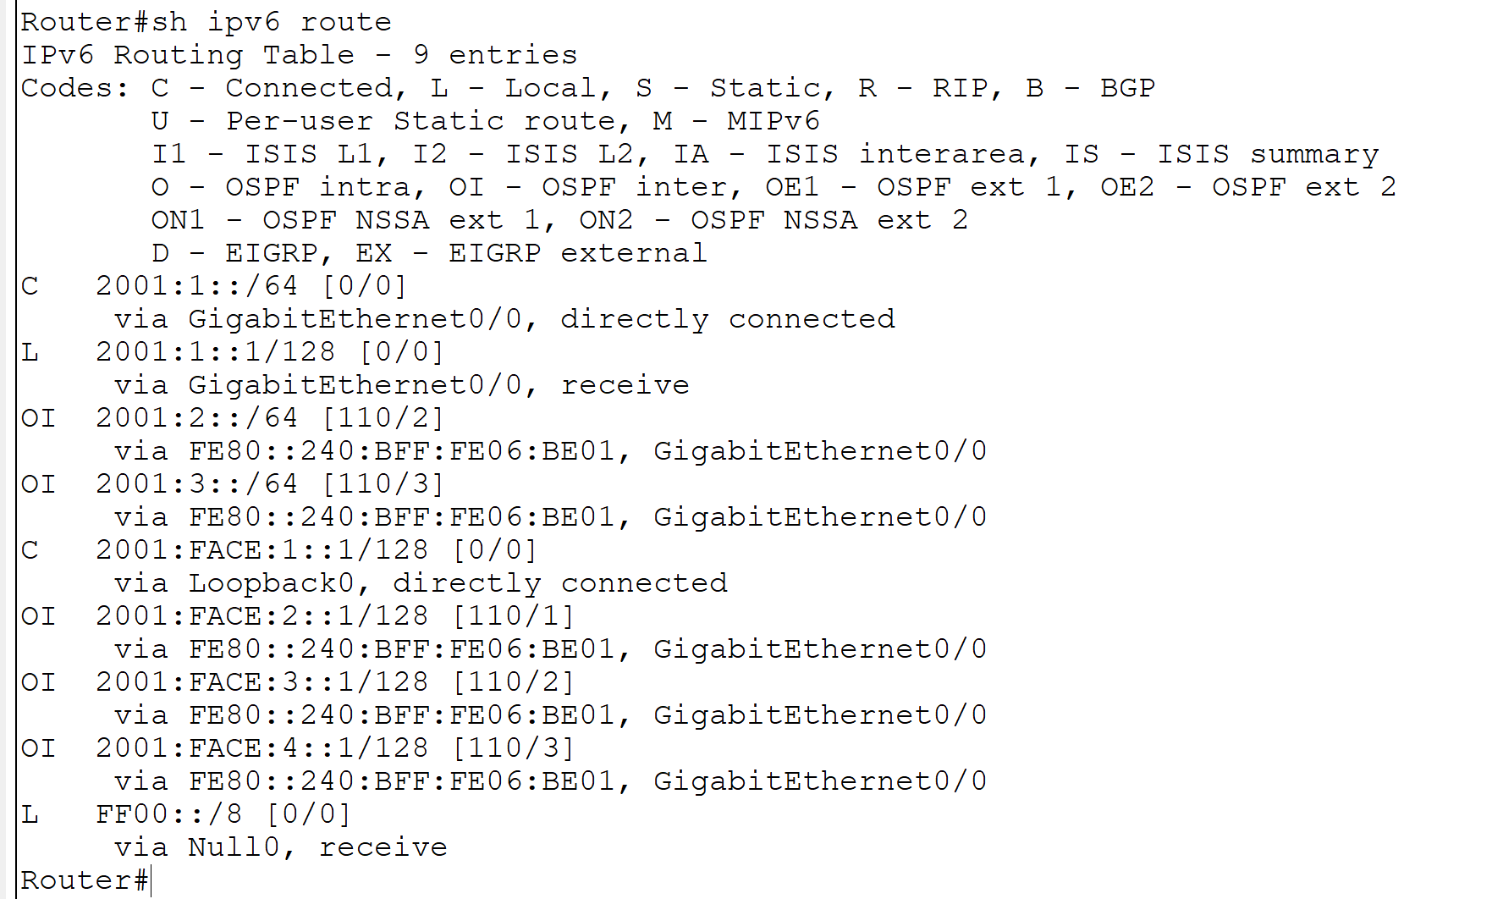

As you can see, all of the OSPFv3 learned routes are indicated as **OI** meaning that these are inter-area routes.

Finally, select a router and try to ping and traceroute some “remote” IPv6 address – since everything is advertised via OSPFv3, all your pings should succeed.

# Exercise 2: Practice the NSLOOKUP command

Note: this exercise assumes NSLOOKUP for Windows. It should be very similar for other operating systems.

## Task 1: Use NSLOOKUP in noninteractive mode

If you need to look up only a single piece of data, use noninteractive mode. Open a command prompt at type:

* **nslookup www.softuni.bg**

What is the meaning of the result? Let’s see an example:

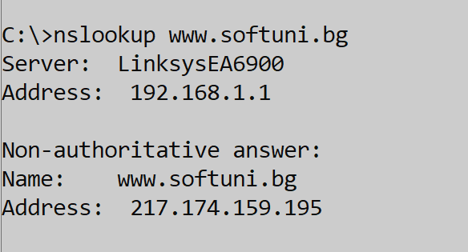

* The Server and Address (the first one) lines show the local DNS server which your client is using at the moment, so the NSLOOKUP command by default makes a query to this server
* The Non-authoritative answer statement means that your local DNS found the information you are looking for but it is not holding this zone
* Last, the Name and Address lines show the actual A record – the IP address to which www.softuni.bg points

## Task 2: Use NSLOOKUP in interactive mode

If you need to look up more than one piece of data, you can use interactive mode. Open a command prompt and type:

* **nslookup** (to enter the NSLOOKUP interactive mode)
* **set type=ns** (to instruct the command to search for a Name Server (NS) records)
* **softuni.bg** (for which domain to search the NS records? Well, for softuni.bg)

Example result:

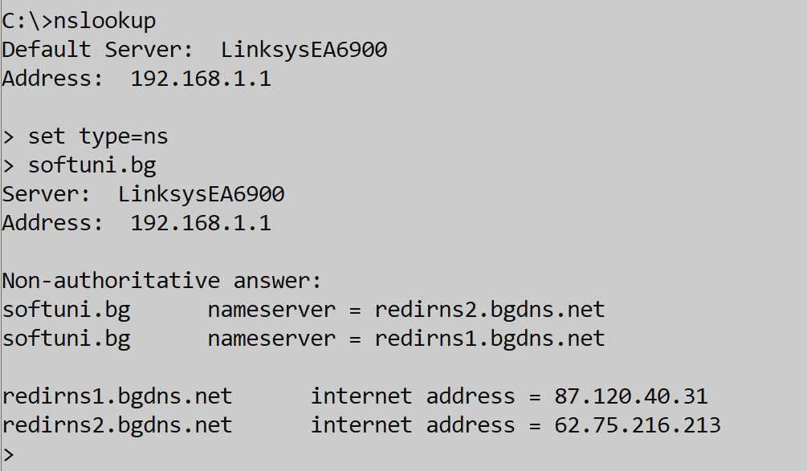

Have a look at the output. It is also Non-authoritative since the local DNS server is not holding these records. Now we have a list with 2 Name Servers, holding the softuni.bg zone. Let’s connect directly to one of them. Still from the NSLLOKUP prompt, type:

* **server redirns2.bgdns.net** (this instruct the NSLOOKUP to connect to a particular DNS server and to start the queries there)

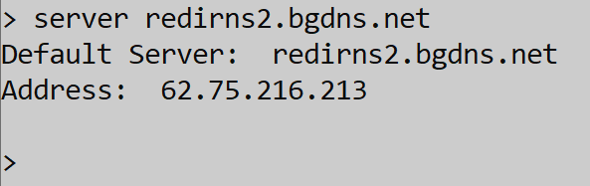

Note: if you have issues with this, point directly to an IP address instead of a name. In this example, type:

* **server 62.75.216.213** (this is the IP address of **redirns2.bgdns.net**)

Now you will ask questions to another DNS server! (Before we asked our local DNS, by default). Let’s ask the same question about the IP address of www.softuni.bg. First, instruct the command what query you are going to make (you will search for A records):

* **set type=a**
* **www.softuni.bg**

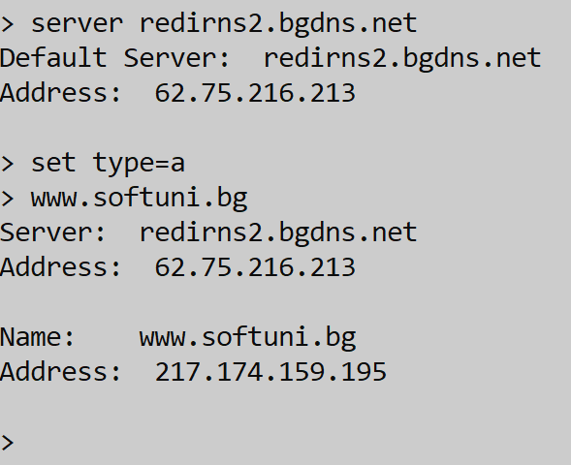

What you see now is a similar output – the IP address of www.softuni.bg is 217.174.159.195. There is a difference though – here you do not see the Non-authoritative answer statement. This means that the answer IS authoritative. And authoritative answer means that the server which is asked (**redirns2.bgdns.net** or **62.75.216.213**) is one of the servers (NS) holding, or responsible for this zone.

Continue to explore NSLOOKUP by changing the servers which you ask (with the **server** command) and by asking different questions / making different queries.

Some examples:

* **set type=SOA** (the start of authority DNS record)
* **set type=NS** (the Name Servers records, as used before)
* **set type=MX** (Mail Exchanger, shows who is the mail server for this domain)
* **set type=A** (the typical A record, showing name-to-IP mappings)

Use NSLOOKUP to query different domains and try to explain the results you receive.

You have completed LAB 4.

# Useful commands for checking your OSPFv3 configurations and troubleshooting

**show ipv6 route**

**show ipv6 interface brief**

**show ipv6 ospf interface**

**show run** (to check if ipv6 unicast-routing is enabled)

**show ipv6 protocols**